Apply Texas Information Sheet
1. To begin go to: Applytexas.org and create an account.
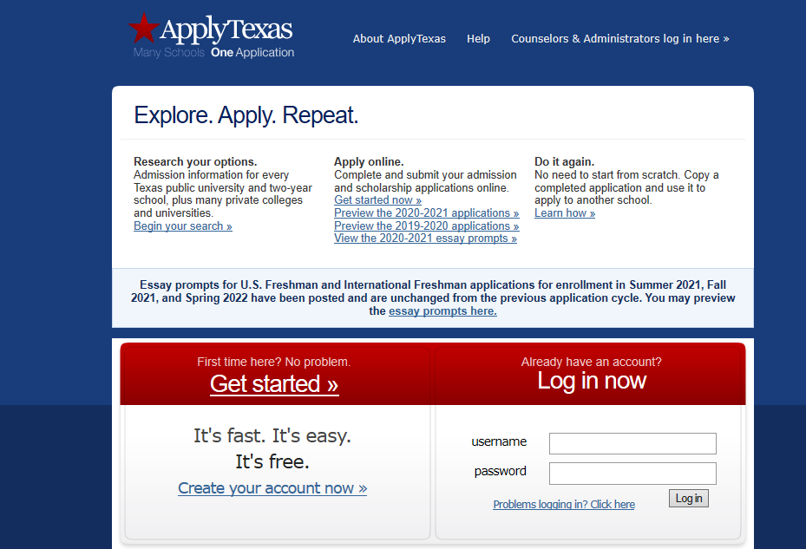
**Your social security number is required for the Apply Texas form
2. Complete Profile
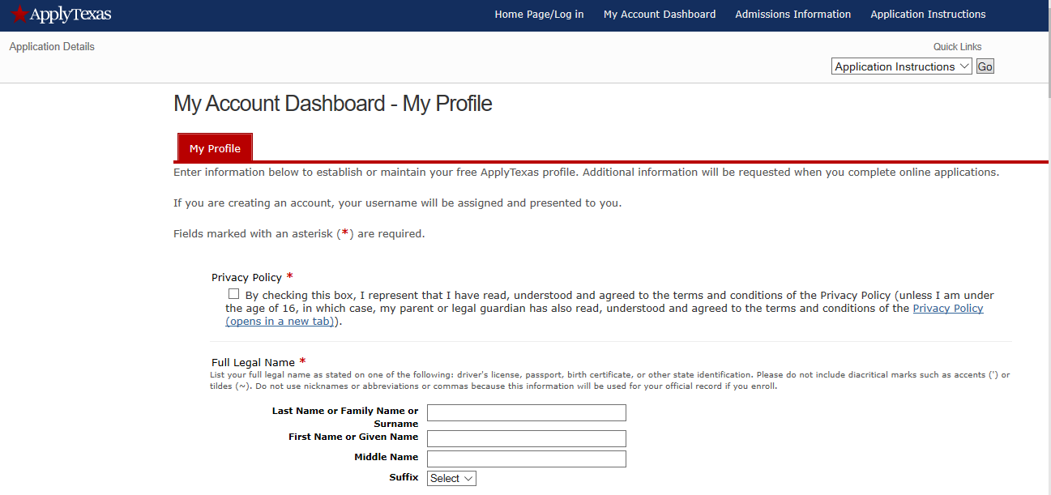
3. Begin Application (Select begin new application)
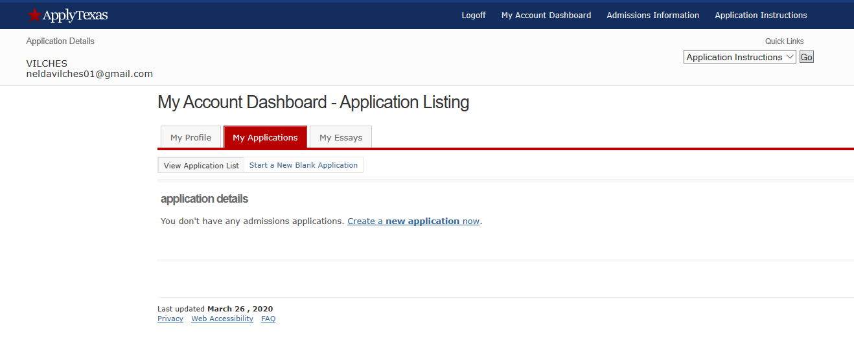

4. Select create a new 2 year application
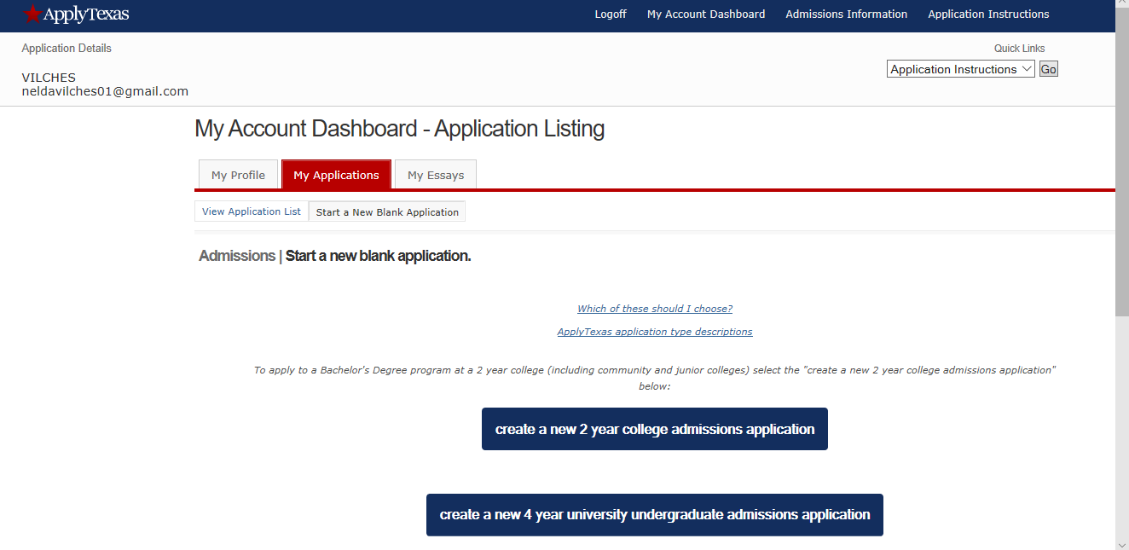

5. Select Target 2 year College Coastal Bend College (Beeville) Home office is housed there
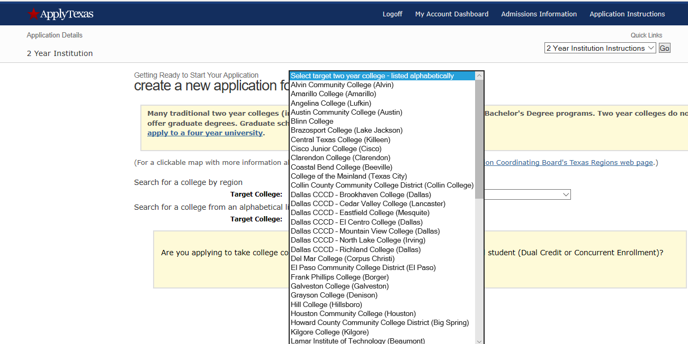
6. Choose the semester you wish to attend.
7. Select major: Click on Associates of science or arts
8. Continue with application. Before you click submit, make sure you look over your application.

